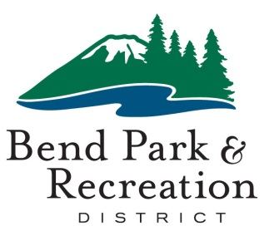
Board of Directors
March 13, 2020
District Office Building | 799 SW Columbia | Bend, Oregon

AGENDA

12:00 p.m. CONVENE MEETING

BUSINESS SESSION
- COVID Virus Update – Don Horton, Julie Brown and Matt Mercer

VISITORS
The board welcomes input from individuals at our public meetings about district-related issues. Meeting attendees who wish to speak are asked to submit a comment card provided at the sign-in table. Speakers will have 3 minutes for comments. If there are questions, follow up will occur after the meeting. Thank you for your involvement and time.

GOOD OF THE ORDER
ADJOURN

Accessible Meeting/Alternate Format Notification
This meeting location is accessible. Sign and other language interpreter service, assistive listening devices, materials in alternate format or other accommodations are available upon advance request. Please contact the Executive Assistant no later than 24 hours in advance of the meeting at sheilar@bendparksandrec.org or 541-706-6151. Providing at least 2 business days’ notice prior to the meeting will help ensure availability.

