Board of Directors
December 15, 2020
District Office Building | 799 SW Columbia | Bend, Oregon

To support Governor Brown’s recommendation for social distancing, the Board of Directors conducted the regular board meeting by video.
View the board meeting via Bend Park and Recreation Facebook page.
BOARD PRESENT
Nathan Hovekamp, Chair
Ariel Méndez, Vice Chair
Jason Kropf
Deb Schoen
Ted Schoenborn

STAFF PRESENT
Don Horton, Executive Director
Michelle Healy, Deputy Executive Director
Julie Brown, Manager of Communications and Community Relations
Lindsey Lombard, Administrative Services Director
Matt Mercer, Director of Recreation
Sheila Reed, Executive Assistant
Brian Hudspeth, Development Manager

5:30 p.m. MEETING CONVENED

VISITORS
Director Hovekamp introduced the visitor’s section and described the procedures to make public comment by email. He said the board has received a lot of comments and letters from the public on SDCs. The board received 47 comments and letters in favor of waiving SDCs and 21 comments for using SDC fees as intended. He said there is a lot of interest on both sides and the letters have been excellent in providing information and perspective. He said he wanted to assure the public that the board reads all letters and they enrich the decisions the board makes. He described the differences between a public comment and a letter to the board, remarking that ultimately both are subject to a public record request. He suggested that all letters for public comment be entered into the public record by attaching them in their entirety to the minutes. The board discussed how they would like to handle public comments from now forward. They acknowledged that reading them is important, but also discussed the time it would take to get through them all when many have been received. Executive Director Horton added that the board does not have to receive public comment, but said it is a best practice. He said when the board receives a couple it is easy to read them, but when many are received it takes away time the board needs to deliberate on agenda topics. Director Hovekamp said the comments will be attached to the minutes and he and the vice chair, Director Méndez will work with staff to come up with a solution.

WORK SESSION
- Receive Budget Committee Applications and Review Process – Betsy Tucker

Ms. Tucker said the district received 6 applications for the two budget committee openings. She said the openings were advertised on Facebook, the Bulletin, district email contacts and board contacts. Ms. Tucker said the board has already received an email with all the applications and explained the scoring system of candidates. She asked the board to email their scores ahead of the next meeting where the board will review the scores and select the new budget committee members.

The board commented about the pool of applicants referring to them all as high caliber.

- COVID Impacts on Recreation Services Budget – Matt Mercer

Mr. Mercer showed a slide to the board that represented impacts to the last fiscal year and the current fiscal year due to the pandemic. He explained the loss of revenue, expense reductions, operating losses, CARES reimbursements and the net loss from additional subsidies. He said the budgets have been impacted by the closures, layoffs with severance, reduced facility operation expenses and materials and CARES reimbursement for childcare.

He next spoke about the costs of Operation Recreation Team Up. He reviewed the costs of the program and spoke about the help that was provided through CARES funding. He projected the costs for January-March of the program and commented that it is unknown if further CARES funding will come through. Without further CARES funding, the district will pay a higher subsidy to the program to keep it going.

Ms. Lombard said she is anticipating a higher subsidy to support recreation services next year to accommodate: a higher demand for needs-based assistance, operation of JSFC and Larkspur Center, to rebuild programs and increases in staffing costs. She said the district’s financial situation today is stable, but still at significant risk from future impacts. She said the district has made up $6.7 million in losses of recreation revenues without using the contingency by reducing expenses. Stating that the contingency would not have covered even half of the losses. She explained that the long-term effects of the pandemic on the economy and revenues are unknown and the district still needs a financial cushion for the future. She added that the risk is much higher in the long term if difficult decisions are not made in the short term.

Ms. Lombard explained the reallocation of property tax resources during the budget planning for last fiscal year and this fiscal year. She said the recreation budget required $1.1 million in a higher subsidy last fiscal year which meant less resources to allocate to the current fiscal year. Last spring, staff made the decision to budget a normal full year for the following: recreation, opening Larkspur, implementing a full year of pay equity and providing COLA and merit increases for employees. This increased the recreation subsidy by an additional $1.6 million over what was budgeted last year. Due to the unknowns, another $1.2 million was reallocated in property taxes to this year’s contingency.

Ms. Lombard next explained that many of the budgeted resources were reallocated to Team Up, JSFC and The Pavilion operations with reduced capacity, child centered programming and to support the economically disadvantaged. The resources for these programs came from the revenue saved from the following areas:
- Layoffs, furloughs, hiring freezes, and reassignments.
- Elected to not provided staff with COLA and merit increases this fiscal year
- Closing facilities

She added that the district will not need to make an adjustment to the budget since spending will not exceed the budget, but will have to reallocate resources. The use of the contingency funds will impact how the district will pay for the provision of services in future years. She said she wanted to make sure the board is comfortable with the direction staff is headed with the allocations.

- System Development Charge and Affordability – Michelle Healy and Lindsey Lombard

Ms. Healy said that this is the third presentation on SDCs and affordability. She said she will provide the following information to help the board to arrive at a decision on the SDC fee waivers.

- Options
- Waiver approval criteria and other City requests
- Project impacts and selection criteria
- Staff suggestion
- Key decision points
- Board discussion
- Direction and next steps

She presented the options as no change to the 400 waivers that have been granted, lift the cap as is or with additional criteria, or provide some additional waivers as is or with additional criteria.

Ms. Healy explained that the first option would leave 20 waivers remaining for affordable housing, adding that this has so far cost the district $2.3 million. This option would not add any further impacts to the level of service. Option two with unlimited waivers, would incur unknown costs in addition to the loss of $2.3M in revenue and reduced level of service is also unknown. Option three would allow for a defined number of waivers that defines the loss in revenue to better plan for the district reduced level of service.

Ms. Healy next spoke about the criteria for waivers showing a slide depicting the current criteria:

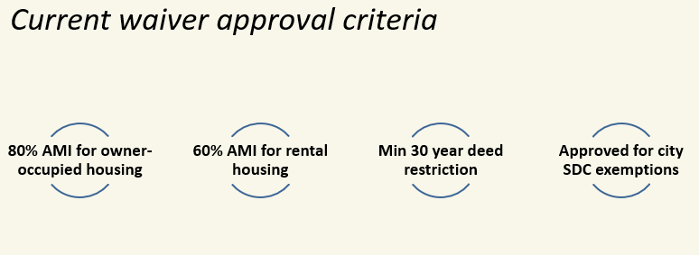

She said the board could consider additional waiver approval. Criteria could include the following:

- Development type
- Developer type
- AMI level
- % award based on size of development (scaled)
- Deed restriction
- Equity of park access
- Other

Next Ms. Healy presented some ideas about requests that could be made to the city to support park SDC waivers:

- Waive/credit city SDCs for district projects
- Exempt park district from affordable housing fee
- Update city code to require park dedication and development, prioritize public open space
- No city fees for AH waiver admin, the city collects the fees on the behalf of the district and keeps a percentage as their fee.

She said that the district has paid an affordable housing fee to the city and over time it has added up to an additional $100,000, she said this fee is likely going up to 1%.

Ms. Healy asked the board to consider other requests to the city:

- Assure park projects are funded in URAs
- Encourage bond or levy for Affordable Housing
- Implement park SDC tiers

The next part of the presentation focused on impacts to the district for waiving SDC fees. She explained that staff used the following criteria to identify projects that would be impacted by the loss of funds.

- Projects are in FY 2021-2025 CIP
- Districtwide significance
- Not a trail or neighborhood park project
- Not a construction project, or with significant expenditures
- Retain projects with alternative funding
- Development over acquisition

Ms. Healy said the following projects have been identified for potential delay or reduction in scope:

- Pine Nursery ($5,000,000), or
- Discovery Park Phase 2 ($650,000) and/or
- Big Sky Bike Park ($3,250,200)

Ms. Healy showed the following slide with the staff suggestion for waivers:

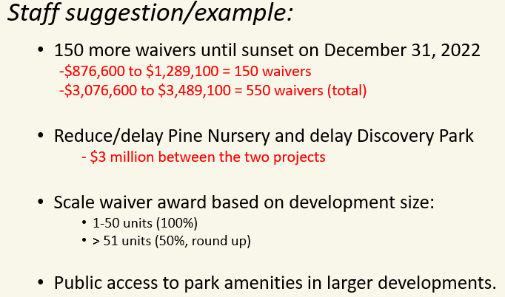

Ms. Healy summarized the key decision points, she asked the board to consider that if they make a change to the waivers that they consider how many more waivers, projects that will be delayed and if additional criteria should be added. She asked the board to keep in mind that the program sunsets in two years and added that this is not likely the last conversation on this topic. She said staff will continue to evaluate in anticipation of the sunset date to learn more about the district impacts.

The board overall agreed that the district has a role in helping with the issue of affordable housing, but also expressed concern for cutting resources that the district uses to help the community. The board would like to see the tiered SDC system in place and acknowledged that the tiers would be helpful for affordable housing units.

The board discussed various aspects of cutting or delaying projects on the CIP. Ms. Healy said some of the costs for Alpenglow Park are coming in a bit lower than expected which helps the CIP budget, but added this type of saving cannot be counted on long-term.

Staff asked the board for direction on the number of waivers and any further plans past the sunset date. Executive Director Horton suggested that there is some urgency for the board to decide on the waivers and suggested that shelters and other living quarters for the homeless could also be made exempt.

The board asked staff to come back at the next board meeting with a draft resolution that can be narrowed in the discussion.

EXECUTIVE DIRECTOR’S REPORT
Executive Director Horton said staff will work with a 320-acre subdivision development project on Steven’s Road for trails and a park. He reminded the board of the canned food drive this Saturday to support Neighbor Impact at the Senior Center and Park and Ride parking lot near The Pavilion and shared that he is proud of the staff that raised $450 to give to a FAN family that lost their home in a fire.
PROJECT REPORT
BOARD MEETINGS CALENDAR REVIEW
GOOD OF THE ORDER
- Director Méndez said he is grateful for everyone’s input on the SDCs.
- Director Kropf said he appreciates people’s time and information provided from staff.
- Director Schoenborn thanked the staff for suggestions on the SDC waivers and added he wants to keep it simple for now. Looks forward to the next meeting and keeping the conversation focused on the resolution.
- Director Schoen thanked the community members for submitting letters, she said many were heartfelt. She also expressed appreciation for the urgency expressed by staff tonight in regard to the SDC waivers.
- Director Hovekamp thanked the board for their good minds and hearts, he said he hopes it is becoming clear to the community that the board is not callous to the economic impacts that are happening in the community. He said that he would like the assumption that the district is a flush agency when there have been so many meetings about cuts and layoffs to come to an end.
ADJOURN 9:28 pm

Prepared by,
Sheila Reed
Executive Assistant

__________________________________ ___________________________________
Nathan Hovekamp, Chair Ariel Méndez, Vice-Chair

__________________________________ ____________________________________
Jason Kropf Deb Schoen

__________________________________
Ted Schoenborn

