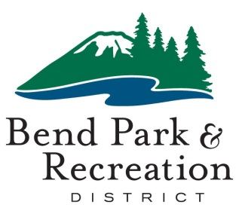**Board of Directors**

December 7, 2021

**District Office Building | 799 SW Columbia | Bend, Oregon**

**AGENDA**

**5:30 p.m. CONVENE MEETING**

**WORK SESSION**

1. Introduction to Board Priorities and Vision – *Ariel Méndez (5 min)*
2. Planning Process Overview – *Michelle Healy* *(30 min)*
3. Board Individual Priorities – *Ariel Méndez (3 min per board member)*
4. Break *(10 min)*
5. Board Reflection and Discussion *(60 min)*

**GOOD OF THE ORDER**

**ADJOURN** 8:30 pm