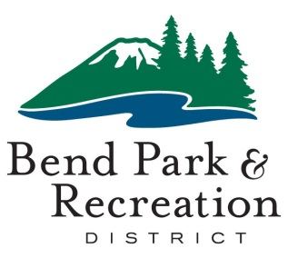**Budget Committee Meeting**

May 13, 2025

**District Office Building | 799 SW Columbia | Bend, Oregon**

⬩ ⬩ ⬩ ⬩ ⬩ ⬩ ⬩ ⬩ ⬩ ⬩ ⬩ ⬩ ⬩

**AGENDA**

The board will meet in person with a virtual link to the regular meeting. The public may provide public input in-person at the meeting or via the virtual Zoom link.

**Please use the link below to join the webinar:**  
<https://us02web.zoom.us/j/85471179843?pwd=301bBTc0OhBXzFbvmfgGzch3cdIGVz.1>

Passcode:424849

**Or Telephone:**

+1 669 900 6833 US

Webinar ID: 854 7117 9843

Passcode: 424849

**4 pm CONVENE MEETING**

**VISITORS**

The board welcomes input from individuals for the fiscal year 2025-26’s proposed budget. Members of the community who wish to make public comment may attend the meeting in person or virtually. **To provide public comment in person, please fill out one of the brief cards and submit it to staff in the back of the room. To provide public comment virtually, click on the "Raise Hand" option. You will be called into the meeting in the order received**. Virtual **visitors should turn on their cameras and microphones. All** remarks should be limited to 3 minutes or less. If there are questions, follow up will occur after the meeting. Thank you for your involvement.

**BUSINESS SESSION**

* Introduction
* Budget Process
* District-wide Budget Summary
* Department Presentations
* Strategic Plan
* Capital Improvement Plan
* Fund Budget Summaries
* Wrap-up Overall Budget and Tax Approval

**ADJOURN**

⬩ ⬩ ⬩ ⬩ ⬩ ⬩ ⬩ ⬩ ⬩ ⬩ ⬩ ⬩ ⬩

Accessible Meeting/Alternate Format Notification

This meeting location is accessible. Sign and other language interpreter service, assistive listening devices, materials in alternate format or other accommodations are available upon advance request. Please contact the Executive Assistant no later than 24 hours in advance of the meeting at sheilar@bendparksandrec.org or 541-706-6151. Providing at least 2 business days’ notice prior to the meeting will help ensure availability.