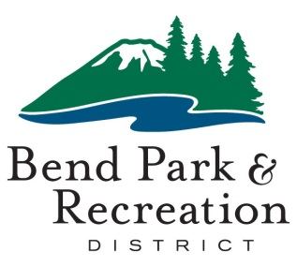**Board of Directors**

July 15, 2025

**District Office Building | 799 SW Columbia | Bend, Oregon**

⬩ ⬩ ⬩ ⬩ ⬩ ⬩ ⬩ ⬩ ⬩ ⬩ ⬩ ⬩ ⬩

**BOARD PRESENT**

Nathan Hovekamp

Deb Schoen

Cary Schneider

Donna Owens

**BOARD ABSENT**

Jodie Schiffman

**Summary of July 15 board of directors meeting**

The BPRD board of directors met on July 15 to discuss two topics in a work-session only public meeting. A video recording is available by request.

To begin the meeting, the board was introduced to a new staff member. Leigh Anne Dennis is the new aquatics supervisor.

**Goose management program**

Zara Hickman and Rob Fox from the Natural Resources and Trails team shared information about the Canada goose management program. BPRD has an ongoing Canada goose management program to address goose damage throughout the district, primarily focused on the river parks and Discovery Park. Large concentrations of geese cause damage to the turf, create riverbank erosion, and leave excessive feces.

Staff provided an overview of on-going efforts consisting of public education, habitat modification, hatch control, hazing and relocation. Additionally, staff reviewed the previous year’s population trends and current challenges to management strategies which continue to be exacerbated by the avian flu.

The board and staff agreed that an update to the management plan, originally created in 2007, would be a valuable future project.

**Larkspur Community Center parking study**

Brian Hudspeth, planning and development director, shared information about a parking study at Larkspur Community Center. Since opening in spring 2021 with parking spaces beyond the requirement by city code, use has increased and is now operating near maximum capacity during peak times and days of the week. There are 240 parking spaces, serving the recreation facility and Larkspur Park.

In 2023, the district decided to locate the new Art Station building within Larkspur Park, without additional parking in the concept due to the type of programs and timing offered by the Art Station. However, since then the programming at the LCC has increased and facility patrons are raising concerns about the additional parking demand the new Art Station could place on existing parking.

To get a better understanding of the parking patterns at the LCC, the district hired Transight Consulting, a local transportation engineering firm, to conduct a parking study. Staff shared information about the parking study and initial ideas for adding parking.

jjThe report suggests highest use is January through April, from mid-morning to early afternoon on weekdays. The recommendation is for the district to consider a modest increase of 25 to 35 parking spaces to accommodate increased parking demands from the Art Station. The spaces could also supplement the parking needed by visitors to the LCC and the park.

Any new parking onsite will require a permit from the city and may also require additional land use approvals. The city code uses a maximum parking standard, which is already exceeded by the current parking levels on site.

The board asked staff to move forward with further research into possible next steps.

The next meeting is Aug. 5.