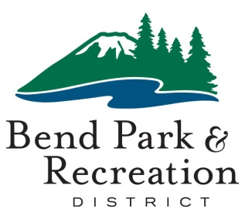
Board of Directors
February 3, 2026
District Office Building | 799 SW Columbia | Bend, Oregon

AGENDA
4:00 pm EXECUTIVE SESSION
The board will meet in Executive Session pursuant to ORS 192.660(2)(e) for the purpose of discussing real property transactions. This session is closed to all members of the public except for representatives of the news media. News media is asked to contact Sheila Reed to attend sheilar@bendparksandrec.org.

The regular board meeting scheduled for 5:30 pm is canceled. The next regular meeting is February 17, 2026.

Accessible Meeting/Alternate Format Notification
This meeting location is accessible. Sign and other language interpreter service, assistive listening devices, materials in alternate format or other accommodations are available upon advance request. Please contact the Executive Assistant no later than 24 hours in advance of the meeting at sheilar@bendparksandrec.org or 541-706-6151. Providing at least 2 business days’ notice prior to the meeting will help ensure availability.

