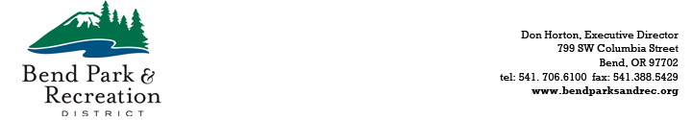

April 14, 2026

PUBLIC NOTICE

A quorum of the Bend Park and Recreation District Board of Directors will meet at the district office, located at 799 SW Columbia Street, Bend, OR, at 9:00 a.m. on April 17, 2026, to participate in the annual budget preparation tour of parks and facilities within district boundaries. This is an informational meeting only; no decisions will be made.

For additional information, please contact: Natalie Macsalka at nataliem@bendparksandrec.org or 541-408-8223.

* * * * * * * * * * * *

